Solution

Use the Pythagorean Theorem  (3/2)^2 + n^2 = (5/2)^2  9/4 + n^2 = 25/4  n^2 = 16/4  n^2 = 4  n= 2  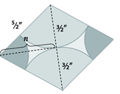 | Use n to find total length of the longer diagonal. Then use the two diagonals to find the area of the rhombus.  The Longer Diagonal  2(n)=2(2)=4  Area of Rhombus  A=1/2(d1)(d2)  A=(1/2)(4)(3)  A=6 in^2

