Hint 1

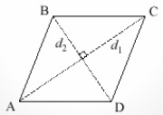

One of the ways to find the area of a rhombus is to take half the product of the diagonals.
A=1/2(d1)(d2)

