Hint 3

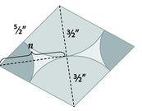

The altitude of the isosceles triangle is half of the longer diagonal (n). Also the hypotenuse of the right triangle created by n is equivalent to the sum of the smaller radius and the larger radius.

