Hint 2

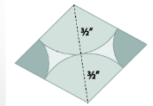

The radius of each large circular leaf is 3/2 inches. That makes the length of the shorter diagonal 3 inches. If we include this diagonal in the figure we can see that two isosceles triangles are formed.

